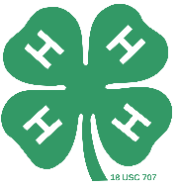
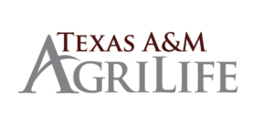

Adult Leader/Volunteer Statement
for
County 4-H Awards Application

For those of you who use the online application form, you must print this document, have it filled out and signed by an Adult 4-H Leader/Volunteer. Then upload this document into your online application.

A statement to be completed by an Adult 4-H Volunteer. Part of being considered for the Hidalgo County 4-H Awards is to receive a short statement from a 4-H volunteer (not agent) who has worked closely with you through your 4-H career. This statement allows the judges to evaluate how others appreciate your leadership and involvement in 4-H.
____________________________________________________________________________________________________________________________________________________________________________________________________________________________________________________________________________________________________________________________________________________________________________________________________________________________________________________________________________________________________________________________________________________________________________________________________________________________________________________________________________________________________________________________________________________________________________________________________________

______________________________ _________________
Signature of 4-H Adult Volunteer

